Capacity Building Programme on Open Education Resources (OER)
Directorate of Quality Enhancement and Department of Education, Virtual University of Pakistan in collaboration with Commonwealth Educational Media Centre for Asia (CEMCA) organized 3-days international online workshop on “Capacity Building Programme on Open Education Resources (OER)” from October 5 to October 7, 2020. The workshop aimed to provide opportunity for:
- Discussing OER and Open Education Practices in World
- Understanding Open Educational Resources
- Finding OER in using Google
- Integration of OER to Teaching and Learning
- Creative Commons Licenses
- Considering Quality Assurance criteria in OER
Mr. Naeem Tariq, Rector Virtual University of Pakistan inaugurated the workshop. He extended the vote of thanks to CEMCA and the resource person for organizing such a thought provoking workshop. Dr. Nantha Kumar Subramaniam from Open University of Malaysia was the resource person for this workshop. He delivered a comprehensive lecture on “Understanding and Using OER”. The workshop was managed by Dr. Madhu Parhar, Director (CEMCA) and Dr. Manas Ranjan Panigrahi, Senior Programme Officer, Education (CEMCA). Faculty members from Virtual University of Pakistan attended the workshop. Given below are the hyperlinks to watch the workshop sessions in detail:
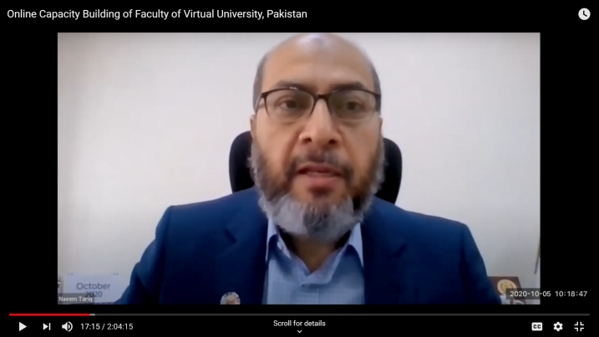 |  | 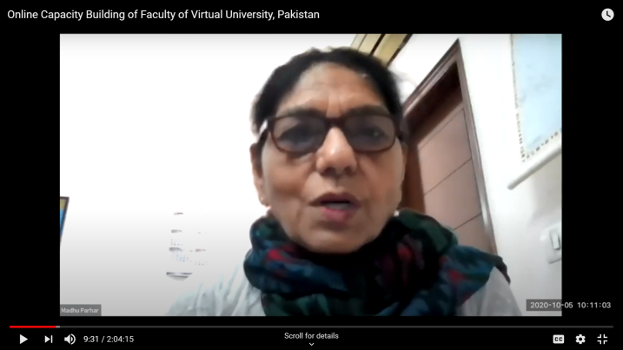
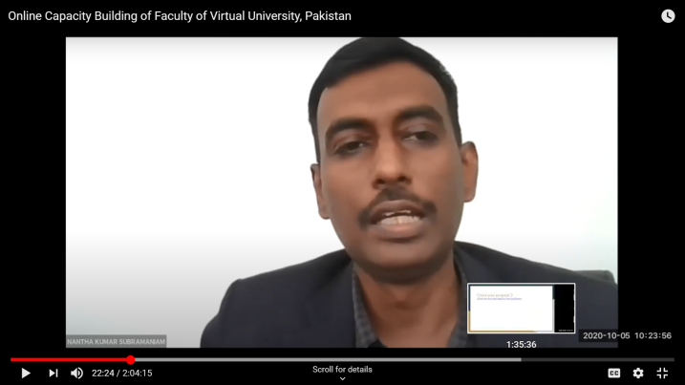 |  | 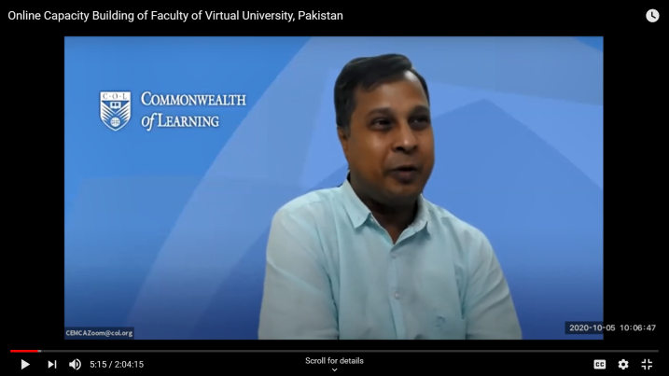
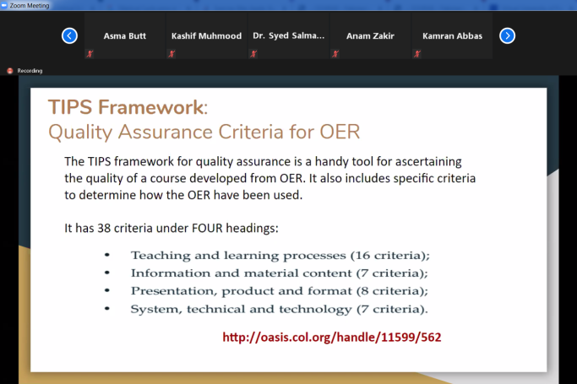 | 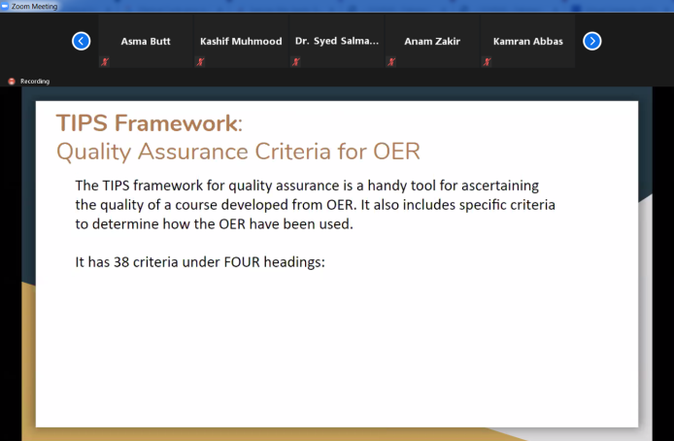

Day 1: https://www.youtube.com/watch?v=CCxcqiiUvP0
Day 2: https://youtu.be/FVG8DYeCNv4

